

**St. Johns Soil & Water Conservation District**

**2022 Poster Contest**

**TOPIC:**

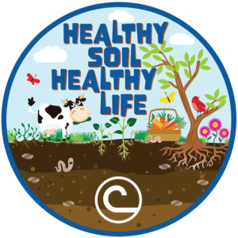

[**RULES:**](http://marionsoilandwater.com/wp-content/uploads/2009/05/Poster-Contest.pdf)

1)   Any media may be used to create a flat or two-dimensional effect (paint, crayon, colored pencil, charcoal, stickers, paper or other materials on regular posters (no computer only entries).

2)   Poster size must be between 8.5″ x 11″ and 22″ x 28″.

3)   Posters must be delivered flat for judging.

4)   All posters must be created by an individual student rather than a team of students.

5)   The 2022 NACD Stewardship Theme “Healthy Soil Healthy Life” must be on your poster.

6)   Each entry must have signed [entry form](http://marionsoilandwater.com/wp-content/uploads/2009/05/entry-poster.pdf) to be eligible for judging.

**JUDGING CRITERIA:**

Ô    **50 points Conservation Message**

Ô    **30 points Visual Effectiveness**

Ô    **10 points Originality**

Ô    **10 points Universal Appeal**

**DIVISIONS: The poster contest is open to kindergarten through twelfth grade students. The entry divisions are (K-1, 2-3; 4-6; 7-9; 10-12)**

**AWARDS:**

1st place: $25

2nd place: $15

3rd place: $10

**DEADLINE:  Deadline to turn in posters is June 15, 2022.** Please deliver posters to St. Johns County Agriculture Center, 3125 Agricultural Center Drive, St. Augustine, Florida 32092. ATTN: St. Johns Soil & Water Conservation District. Please email a copy of the poster and registration to gina.allen@fl.nacdnet.net